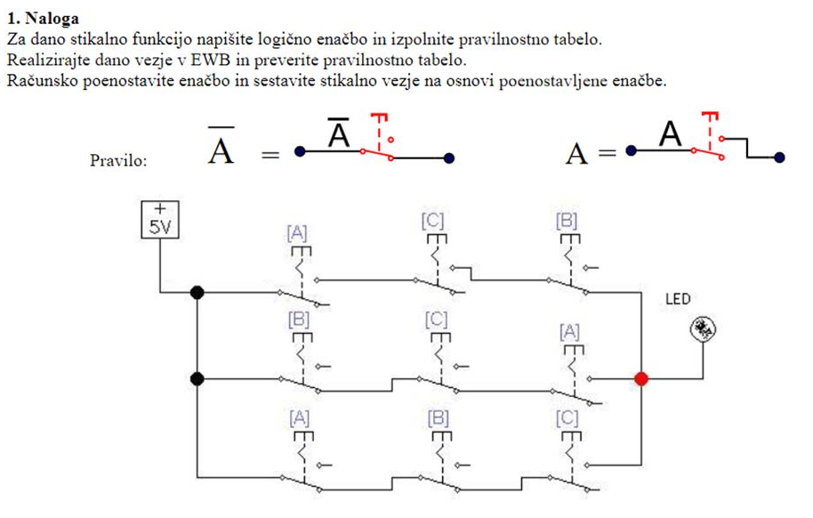

A/B C + A/B/C+/A/B C

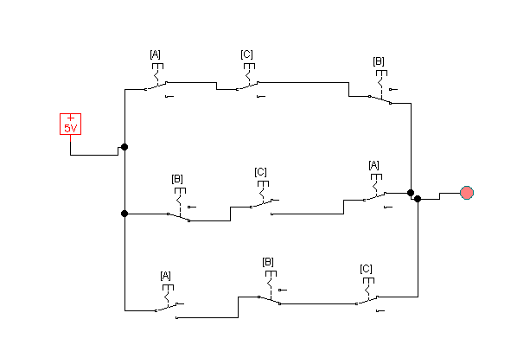

|  |  |  |  |
| --- | --- | --- | --- |
| A | B | C | Y |
| 0 | 0 | 0 | 0 |
| 0 | 0 | 1 | 1 |
| 0 | 1 | 0 | 0 |
| 0 | 1 | 1 | 0 |
| 1 | 0 | 0 | 1 |
| 1 | 0 | 1 | 1 |
| 1 | 1 | 0 | 0 |
| 1 | 1 | 1 | 0 |

|  |  |  |  |  |
| --- | --- | --- | --- | --- |
|  | A | |  |  |
| B |  |  |  |  |
|  | 1 | 1 | 1 |  |
|  |  | C | |  |

A/BC + A/B/C +/A/BC

/B(AC+A/C+/AC)

/B(A(C+/C)/AC)

/B(A+/AC)

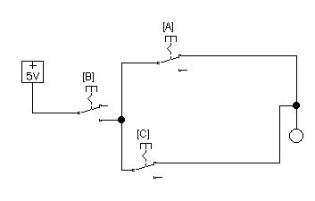

A/B + C/B

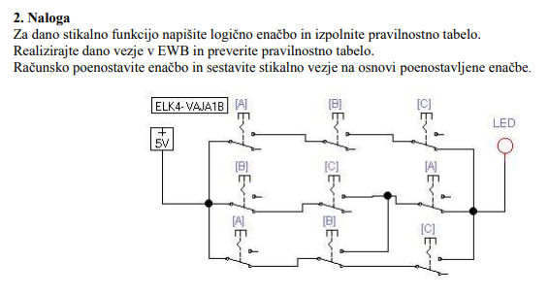

AB $\overline{C}$ + $\overline{B}$ C $\overline{A}$ + $\overline{A}\overline{B}$ C+ $\overline{A}$ B

|  |  |  |  |
| --- | --- | --- | --- |
| A | B | C | Y |
| 0 | 0 | 0 | 0 |
| 0 | 0 | 1 | 1 |
| 0 | 1 | 0 | 1 |
| 0 | 1 | 1 | 1 |
| 1 | 0 | 0 | 0 |
| 1 | 0 | 1 | 0 |
| 1 | 1 | 0 | 1 |
| 1 | 1 | 1 | 0 |

|  |  |  |  |  |
| --- | --- | --- | --- | --- |
|  | A | |  |  |
| B | 1 |  | 1 | 1 |
|  |  |  | 1 |  |
|  |  | C | |  |

C $\overline{A}$ +B $\overline{C}$

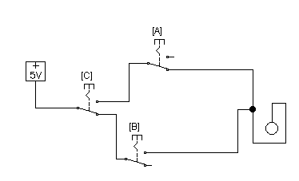

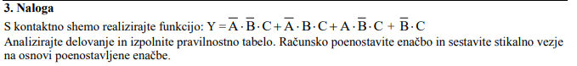

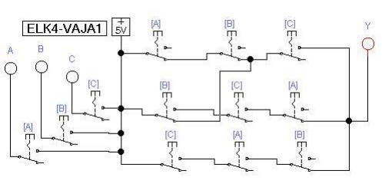

|  |  |  |  |
| --- | --- | --- | --- |
| A | B | C | Y |
| 0 | 0 | 0 | 0 |
| 0 | 0 | 1 | 1 |
| 0 | 1 | 0 | 0 |
| 0 | 1 | 1 | 1 |
| 1 | 0 | 0 | 0 |
| 1 | 0 | 1 | 1 |
| 1 | 1 | 0 | 0 |
| 1 | 1 | 1 | 0 |

|  |  |  |  |  |
| --- | --- | --- | --- | --- |
|  | A | |  |  |
| B |  |  | 1 |  |
|  |  | 1 | 1 |  |
|  |  | C | |  |

C $\overline{B}$ +C $\overline{A}$

